Part 1: Autonomous Shipment's Trial: Driving the Future of Delivery
- Introduction to the Business problem:
In today's complex world, decision-making often involves weighing multiple factors. Multi-Criteria Decision Analysis with the Weighted Sum Model (MCDA WSM) offers a structured approach to this challenge. Picture a city planner deciding between different transportation projects. MCDA WSM aids by considering factors like cost, environmental impact, and public opinion, assigning weights to each based on importance. Then, it combines these factors to rank the projects objectively. However, applying MCDA WSM isn't always straightforward. For instance, in healthcare, choosing between treatment options involves balancing effectiveness, cost, and patient preferences. This report delves into how MCDA WSM works in such real-world scenarios, providing insights into its benefits and complexities. Whether managing resources, evaluating policies, or making personal choices, understanding MCDA WSM can empower decision-makers to make more informed decisions.

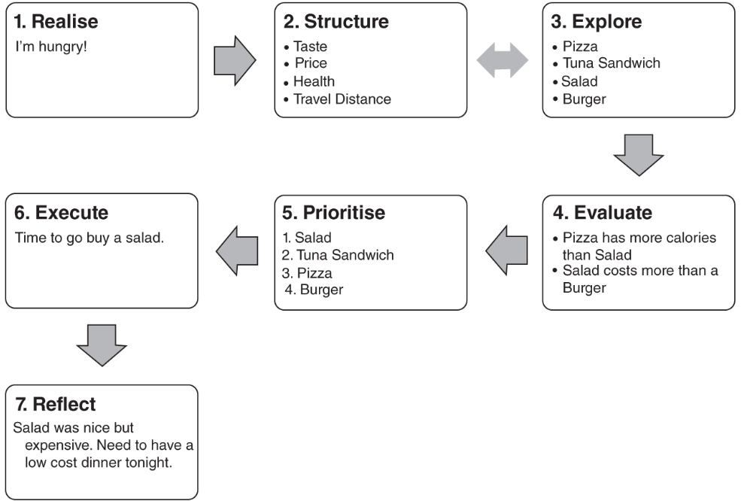

1.1. Utilization of MCDA in Decision-Making:
Multi-Criteria Decision Analysis (MCDA) is a valuable tool employed across diverse fields to aid decision-makers in evaluating complex alternatives. For instance, in urban planning, MCDA assists in selecting the most suitable location for a new public park by considering factors like accessibility, environmental impact, and community preferences. Similarly, in business, MCDA helps companies choose between investment opportunities by weighing criteria such as profitability, risk, and market demand. Moreover, in environmental management, MCDA guides policymakers in prioritizing conservation efforts based on ecological significance, feasibility, and stakeholder engagement. By systematically analyzing multiple criteria, MCDA enables decision-makers to make well-informed choices that align with organizational goals and societal needs. Through real-world applications like these, MCDA continues to demonstrate its effectiveness in addressing complex decision-making challenges across various domains.

In the realm of Multi-Criteria Decision Analysis (MCDA), several key terminologies help in understanding the decision-making process. One such term is "criteria," which refers to the different factors or attributes considered when evaluating alternatives. For example, in selecting a new location for a retail store, criteria may include proximity to target customers, rental costs, and accessibility. Another essential term is "weights," which represent the relative importance of each criterion in the decision. For instance, if customer proximity is deemed more critical than rental costs, it would receive a higher weight. Additionally, "alternatives" are the different options or choices available for selection. Continuing with the retail store example, alternatives could be different potential locations under consideration. Understanding these terminologies enables decision-makers to systematically assess alternatives and make informed choices that align with their objectives.

1.2. WSM Methodology:
The Weighted Sum Method (WSM) is a popular technique in Multi-Criteria Decision Analysis (MCDA), valued for its simplicity and effectiveness. Also known as The Simple Additive Weight method (SAW) or The Simple Multi-Attribute Rating Technique (SMART), WSM involves assigning weights to criteria based on their importance in decision-making. For example, when choosing a new product to develop, factors like market demand, production cost, and competition may be weighted accordingly. These weights are then multiplied by the performance scores of each alternative on the respective criteria. By summing up these weighted scores, decision-makers can objectively compare alternatives and select the most favorable option.

WSM's straightforward approach and broad applicability make it a valuable tool across various industries and decision contexts. Its ease of use allows decision-makers to quickly assess alternatives and make informed choices, whether in project selection, resource allocation, or policy formulation. With its transparent methodology and tangible results, WSM continues to assist decision-makers in navigating complex decision landscapes and achieving their goals effectively.

Min-Max Criteria | Carrying Capacity  (Litres) | Battery Size  (Hours) | Average Speed  (Km/h) | Cost Per Unit  (GBP) | Reliability  (Hours)
Min-Max Criteria | Max | Max | Max | Min | Max
Figure 1.1.2.1: Min-Max Criteria

PIS | Carrying Capacity | Battery Size | Average Speed | Cost Per Unit | Reliability
PIS | 0.03 | 0.12 | 0.09 | 0.15 | 0.25
NIS | 0.02 | 0.06 | 0.04 | 0.06 | 0.17
Figure 1.1.2.2: PIS and NIS Values

1.3 Advantages of WSM:

WSM stands out among MCDA techniques for its simplicity. Unlike other methods that can be complex and require specialized skills, WSM is straightforward and easy to use. For instance, imagine a company deciding between different projects. With WSM, they can easily assign weights to factors like cost and potential profits, helping them make a quick and informed choice. Moreover, WSM makes decision-making transparent, so everyone involved understands why certain decisions are made. This clarity builds trust and teamwork among decision-makers, leading to better outcomes. In essence, WSM's simplicity and transparency make it a practical and effective tool for making tough decisions in the real world.

1.2. Working example of WSM:

To effectively apply the Weighted Sum Method (WSM) in decision-making, a systematic approach is employed. Firstly, the alternatives under consideration are identified. In the present example, three cars are being evaluated: Vauxhall Corsa, Renault Clio, and Ford Fiesta. Subsequently, the relevant criteria for the decision-making process are determined. In this scenario, four criteria are identified: Purchase Price, Economy (measured in miles per gallon), Aesthetics (rated out of 10), and Boot Capacity (measured in liters).

<>

Weights are then assigned to each criterion to signify its importance in the decision-making process. These weights are allocated such that they sum up to 100%, ensuring a proportional representation of preferences across all criteria.

<>

Normalize the data to ensure that all criteria are on the same scale. This step is crucial to prevent biases in the evaluation process and involves adjusting the scale of each criterion so that they are comparable. For instance, if the criteria have different units of measurement, such as pounds for Purchase Price and miles per gallon for Economy, normalization procedures are applied to standardize the data.

Invert the values of any minimization criteria to ensure consistency with the maximizing nature of the other criteria. For example, Purchase Price, being a minimization criterion, is inverted by taking the reciprocal (1/Purchase Price), transforming it into a maximizing criterion where higher values indicate better performance.

Calculate the WSM score for each alternative by multiplying the value of each criterion by its respective weight and summing the products. The alternative with the highest WSM score is deemed the optimal choice.
1.2.2. Choice of Optimization method:

The linear optimization technique is selected as the appropriate method for this task. This method is particularly well-suited for problems with a single objective function that aims to either maximize or minimize while considering linear constraints. In this specific case, the primary objective is to maximize the number of completed orders per day, making linear optimization the most fitting approach. Goal programming and lexicographic goal programming are typically employed when dealing with multiple conflicting objectives that need to be simultaneously optimized.

Constraint | Grocery Store | Clothing Store | Sport Equipment Store | Actual | Target
Cost | 8700 | 8100 | 7700 | 244300 | 250000
Labor | 10 | 7 | 5 | 250 | 250
Number of Orders | 9 | 6 | 4
Min No of Robots | 5 | 5 | 5
 | xg | xc | xs
Decision Variables | 19 | 5 | 5 |  | Maximized Number of Orders per day
 |  |  |  | Objective function: | 221
Figure 1.2.2.1: Linear Optimization Table

The overarching objective revolves around maximizing the daily orders delivered by drones, forming the core equation for optimization. Simultaneously, the solution must factor in constraints related to costs, labor, and lower limits to ensure a practical and viable outcome. Balancing the imperative to achieve the maximum number of deliveries with the real-world limitations of costs, labor availability, and the need to adhere to lower limits, forms the crux of this optimization problem.

Recommendation on Allocation Strategy:

In line with the Linear Optimization analysis results, the proposed strategy for the trial involves deploying 29 autonomous robots across various stores to efficiently handle a maximum daily order volume of 221. To achieve this, a customized allocation plan assigns 19 robots to the grocery store, while clothing and sports equipment outlets each receive 5 robots. This tailored distribution not only keeps the overall cost well within the allocated budget of 250,000 GBP but also optimizes order fulfillment, ensuring strict adherence to financial constraints. Furthermore, it aligns with the weekly labor cap of 250 hours and stays within the defined workforce limitations, ensuring a balanced and resource-efficient approach to the trial's objectives. The recommended strategy, which respects labor and financial limits, is a wise and practical choice that will improve order delivery efficiency.

Figure 1.1.3.1: Robot Allocation Strategy – Recommended

Response to Management:

After extensive investigation, the "Deviant" robot emerges as the prime candidate for our upcoming experiment, showcasing remarkable performance in critical aspects such as battery life, speed, and reliability. Despite a slightly higher individual cost and a marginal reduction in carrying capacity, the "Deviant" aligns perfectly with our business objectives.

In accordance with our strategic plan for the trial, we propose the deployment of 29 autonomous robots. A carefully devised allocation strategy allocates 19 robots to the grocery store, with 5 each assigned to the clothing and sports equipment stores. This recommendation is grounded in the meticulous selection of the most suitable robots, ensuring not only the optimization of order fulfillment but also strict adherence to predetermined constraints.

